TEAM ID: PNT2022TMID40558

TEAM LEADER: JAYAMANI M MEMBER 1: PANDIYARAJA R MEMBER 2: GOWTHAM J Member 3: THENMOZHI T MENTOR: G.Suganya

IBM CLOUD SERVICES

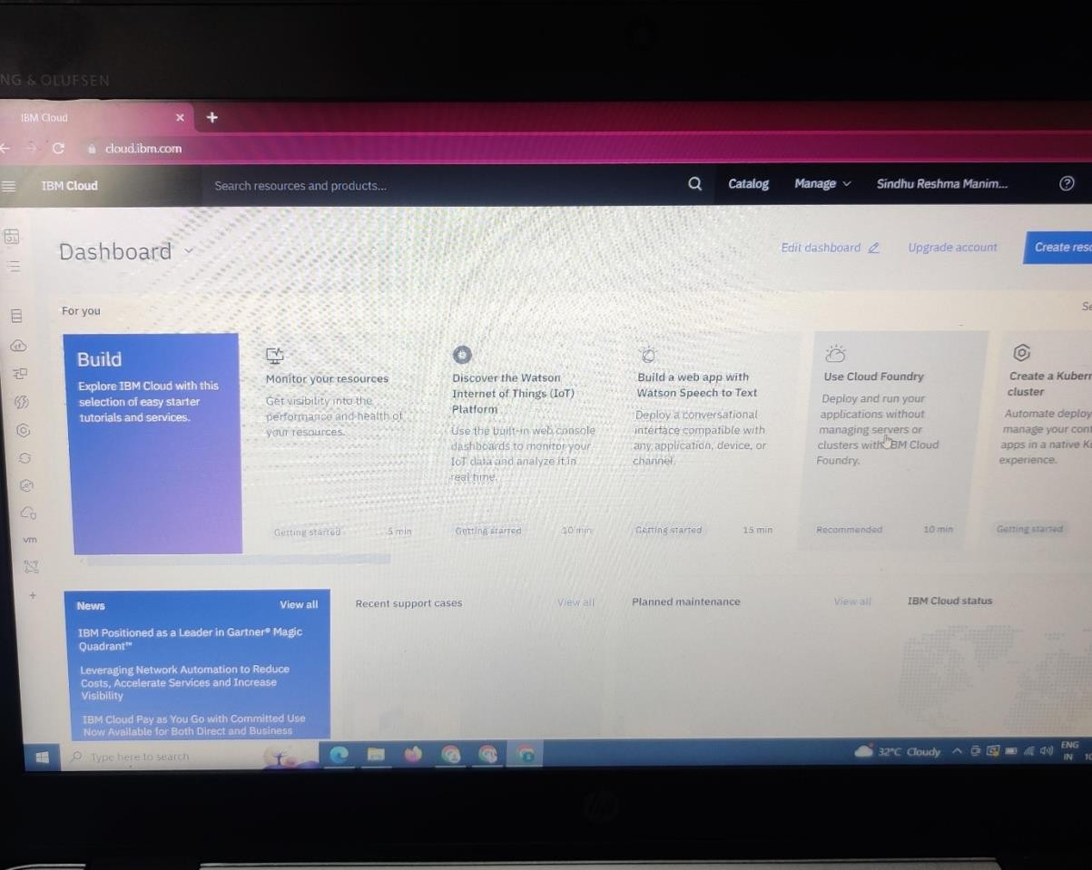

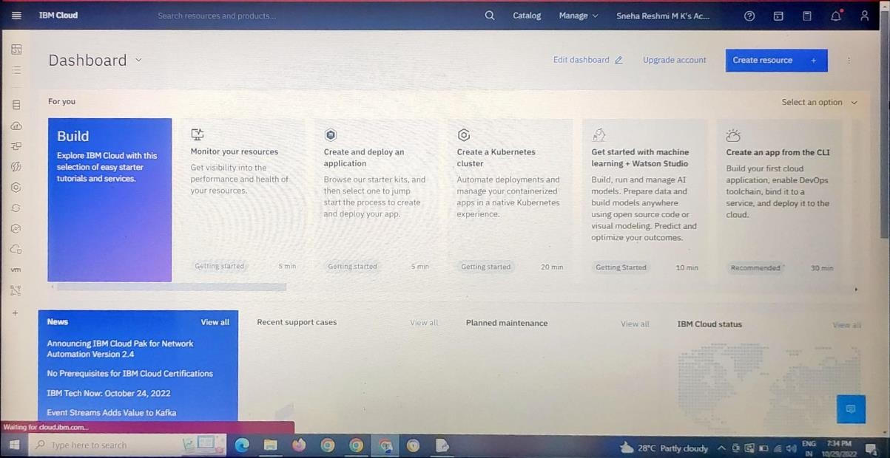

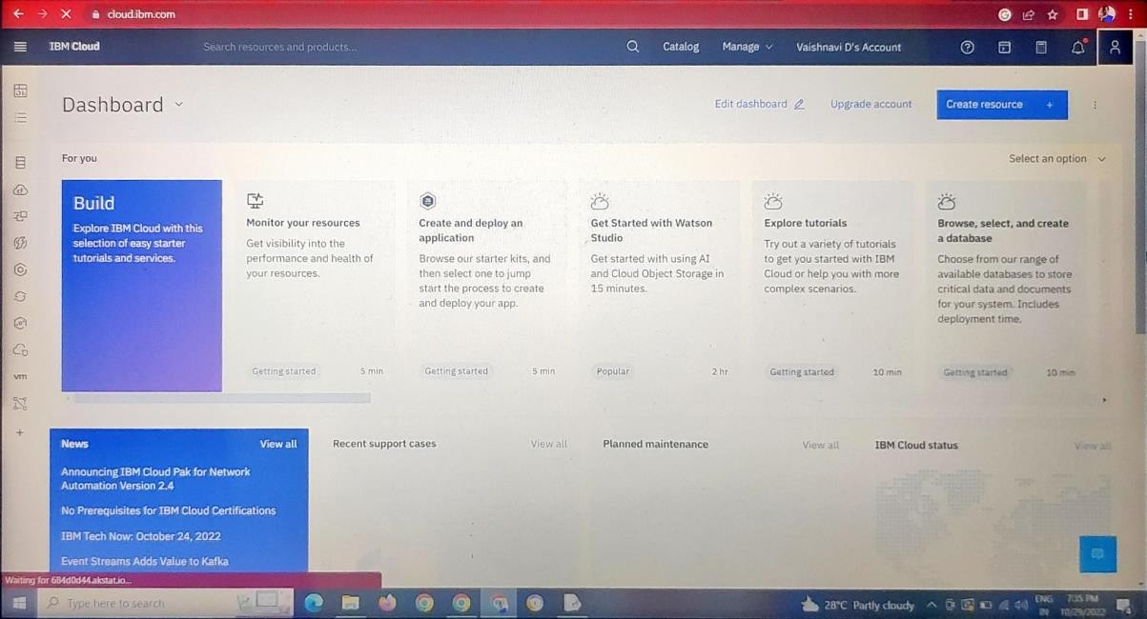

I

